ABSTRACT
This paper aims to report part of the findings from a project that addressed young people’s perceptions of self and community in the North East of England. The starting point has been a realization that policy initiatives which address children’s well-being in community are heavily concentrated either on very young children (early years and primary school) or young people (aged 14 to 19). Thus, the original project was aimed at young people aged between 11 and 14; having moved from primary to secondary school, these children appeared to be considered neither as children nor as young people. The researchers wanted these young people to have an opportunity to express themselves about issues specifically relevant to them. The study used a multi-method approach (use of scrapbooks, questionnaires, interviews, focus groups) in three secondary schools to collect its data. This paper reports and discusses findings from interpretation of scrap book imagery used with Year 7 pupils (73 male and 21 female) and four items (out of 18) of the questionnaire only. The findings suggest that the young people surveyed here had a strong sense of their own identity, though confidence in this identity does not appear to be reflected in their perception of how teachers and other professionals see them.

Key Words: pupil voice, identity, secondary age phase, self expression and young people’s perspectives, transition

Introduction
The starting point for this study was the University’s involvement in a forum called Developing Knowledge Transfer Partnerships: Establishing Research Priorities for 11-14 year old young people in the Tyne and Wear conurbation. Front line professionals noted a demand for further investigation but were without resources to develop such projects. The forum highlighted the need for further research into this age phase of young people within the region and particular localities. Therefore an outcome identified was to develop a far greater understanding of issues for this age group hence the rationale for this study.
The context for this project recognises that promoting children and young people’s well-being is of great importance and underpins fundamental aspects of current policy and legislation across the UK. Such policy initiatives have seen the development of Local Safeguarding Children’s Boards emerge as the basis for integrated working between a wide range of professionals across the private, voluntary and public sectors. Such partnership working is complex and requires consideration of the ethics of information sharing not solely within area specific Local Safeguarding Boards but also between one geographical location and another. Promoting children and young people’s ‘well-being’ requires consideration of the multiple influences upon children and young people’s development and learning. Priorities for children and young people can be individually or geographically located making target and key performance indicators difficult to identify or achieve in full (Ben-Arieh, 2010). Whilst steps have been taken in tackling such wide ranging issues much of this work relates to those young people aged 14-19 or within the primary and early years phase for children up to age 11. This project originally provided the opportunity for those young people aged 11-14 to raise issues specifically relating to this age phase from the young person’s point of view. This paper concentrates on the Year 7 pupils following their transition into Secondary School and will allow for consideration of young people’s choices that impact directly upon their short and long term well-being. In this way the project will provide a voice for 11-12 year olds specifically and those professionals who work with this age phase.

Literature Review

Children between the ages of 11 to 14 years old are within the stage of adolescence, which for some children can be a difficult and confusing stage of their life. Adolescence is a transitional stage or bridge between childhood and adulthood, occurring between age ten and nineteen (Crawford, 2006; Paludi, 2002). It is a critical phase in an individual’s life; a phase characterised by physical, psychological/cognitive, social and emotional development (Boyd and Bee, 2012; Lerner, 2001; Peterson, 1988). A psychosocial perspective can assist society to seek an understanding of individuals’ internal experiences that are a product of interactions among biological, psychological and societal processes (Newman and Newman, 2012). The psychosocial perspective, developed by Erikson (1963), maintains that human development is the result of the continuous interaction of the individual and the social environment (ibid). Adolescents within this important developmental stage, must achieve their own sense of personal identity. Personal identity can be defined as an understanding of one’s unique characteristics and how they are manifested across ages, situations and social roles (Boyd and Bee, 2012). Erikson (1968) argued that a child’s early sense of identity comes disconnected in early adolescence because of the combination of rapid body growth and sexual changes experienced during puberty. For adolescents undergoing such physical changes of puberty can prompt fluctuations of self-image and a re-evaluation of who they really are (Steinburg, 2002).
Importantly, Erikson (1968) found that adolescents, as a result of puberty, became aware that their old identity would no longer suffice and a new identity must be formed. Erikson (1968) also suggested, adolescents are mindful that their new identity must equip them for the myriad of roles associated with adult life such as career roles, sexual roles and religious roles. Confusion about these role choices can be expected and can lead to a pivotal transition of identity crisis, a period during an adolescent is troubled by a lack of identity (Heaven, 2001; Coleman, 2011). Therefore is it not unusual for adolescents to explore some identity roles which are more radical than others, and more final role commitments do tend to be more conservative (Kaplan, 2000). It is not unusual for adolescents, engaged in an identity crisis, to show more conflict with parents and authority figures (Heaven, 2001). In Erikson’s explanation (1968, pg. 174), and later endorsed by Arnett (2009), ‘negative identity’ involves some adolescents deliberately rejecting the range of acceptable possibilities and roles offered by society, and instead deliberately embracing what society considers unacceptable, contemptible and offensive.
During the adolescent stage, friendships are often used as a defence against the emotional turmoil engendered by a lack of a coherent identity (Erickson, 1968). Friendships and peer groups are an important source of emotional support for adolescents going through the complex transition of adolescence (Papalia et al., 2001). Adolescents, going through such rapid changes and transitions, take comfort from being with others who are going through the same changes (ibid). It therefore can be expected, that there is a fear of losing friendship liaisons, in favour of individual constructed family values.
A related but alternative view of social identity during this transition is provided by Jenkins (2004) when he suggested all children from birth are influenced by, and to a lesser extent, influence, those around them. As children become young people, this external-internal dialectic of identification changes with less significance being placed upon external, familial factors, and greater significance upon the peer group, often gendered, as an influencing force upon a young people’s identity. He also claims that gender remains a primary identity, i.e. categorically intrinsic to identity and therefore not just unquestioned, but rather having their gender identity reinforced. However this internal element, the reflexive interpretation of their milieu, becomes more significant asking not only what sort of person am I, but how are others seeing me? Further, young people come to accept (if not always taking responsibility for) that they have an impact upon others, both positive and negative: ‘It is by means of reflexiveness… which enable the individual to take the attitude of the other towards himself’ (sic) (Mead, 1934, p 134). Relationships are then negotiated, and negotiable to some extent (James, 1993, cited in Jenkins, 2004) and the selection of a peer group is by necessity, a de-selection of others (Riddell, 2010). Jenkins (2004, p66) claims that ‘the peer group is definitively political’, social milieux where divisions come and go, alliances are made and dissolved, where conflicts erupt, fizzle and fizzle out. The social space where public image is everything is in both the real and digital worlds. Young people in their early teens are transitioning through these internal-external dynamics, mirroring adulthood ‘with its strategies, its games, its stratification and its rules’ (Jenkins, 2004, p66) attempting to navigate and establish a solid sense of self, therefore presenting this is who I am. However, identity, as Jenkins (2004) argues, is neither permanent nor entirely plastic and always, by necessity, flexible and contingent.
This Is also confirmed to a certain extent by Blakemore’s work (2012), using MRI scanning techniques, that suggests that the adolescent brain needs to ‘develop the ability to take into account someone else’s perspective in order to guide on-going behaviour…’ This, she continues, develops through to early adulthood. In addition there are variances between male and female whereas females develop this ability earlier.
Friendships and peer groups are an important source of emotional support for adolescents going through the complex transition of adolescence (Papalia et al., 2001). Adolescents, going through such rapid changes and transitions, take comfort from being with others who are going through the same changes (ibid). It therefore can be expected, that there is a fear of losing friendship liaisons, in favour of individual constructed family values.
Social capital can be considered as a factor in a young person’s self-perception; social status and in their ability to make a successful transition from primary to secondary school. The key element within the concept is the relationship with others via some kind of durable social network. McGonigal et al (2007) citing Bourdieu and Passeron (1977) claim that social capital is intrinsically relational with attendant emotional and perceptual consequences and as a metaphor for capital can be used to explore aspects of the social world and the social reproduction of social classes. The state of civic engagement in the USA (Putnam, 2000) and unequal educational attainment in the USA (Coleman, 1990) suggest that social capital is double-edged: both promoting self-interest and building communities.

Methodology
This project adopted a multi-method approach to provide young people aged 11 to 14 years old with a voice to express their experiences in relation to how they see themselves vis-a-vis home environments, local resources and schooling. The research team argued that an eclectic range of research tools within a pragmatic methodological framework would be more appropriate than any single method or dogmatic adherence to a particular methodological paradigm. However, the aim of providing children with a voice is not without its problems. Researchers have developed more child-centric approaches, moving away from seeing children as the passive recipients of developmental processes to approaches that see children as active agents in their own lives (James and Prout, 1990), distancing themselves from imposing research structures upon children and developed alternative research approaches where children’s authentic voice can only be heard if they are engaged in the research process as equals. This tilt towards child-centric research has been questioned by the likes of Buckingham (1991); Gallacher and Gallagher (2008); Holland et al (2010); Hunleth (2011) and Lomax (2012). Lomax (2012), using participatory visual and creative methods with young people, found that some children were intentionally and unintentionally excluded from expressing themselves due to a variety of factors including insufficient skills to operate the technology effectively; ineffective skills when interviewing each other (leading to directed responses and truncated interviews); self-censorship and deliberate exclusion because some children’s responses may be seen as ‘uncool’. Lomax (2012) goes on to suggest that participatory methods involving children and young people need to be conducted with skill and awareness of the potential problems that these methods involve. It is with these kinds of reservations in mind that the research team deemed it necessary to both direct and support the involvement of children in the gathering of data to ensure that all children had the opportunity to express themselves in their own ways in both the questionnaires (via open questions, as well as closed questions) and the scrapbooks (see below for further details). The scrapbooks were completed over a period of days at school, during which time the questionnaires were also administered.
The project worked with three secondary schools. This sample was established in part from opportunity (i.e. established contacts) and in part via purposive sampling (to provide the sample with a variety of characteristics). Each school then had different elements to the other two schools. In total the schools encompassed both single sex and co-educational cohorts; both religious and secular schools; a school with a largely middle class intake and a school with a largely working class intake; a school which had recently been in ‘special measures’ and an ‘outstanding’ school; a school where parent involvement was high and a school where it was low. Pupils were originally drawn from year groups 7, 8 and 9; though the numbers drawn were not uniform from across the three schools, i.e. different schools provided access to different year groups with one providing access to whole cohorts, whilst others allowed children to self-select. The gender imbalance reflects the high boy birth rate in Sunderland. The entire data gathering took place either in lunchtimes or during Personal Social and Health Education classes (PSHE). This data represents year 7 only. Research for this paper addresses four questions from the questionnaire and imagery from the scrapbooks.
The first activity of the data collection involved introducing the scrapbook activity. The first page of the scrapbook involved pupils considering how they perceived themselves, the second page focused on how they felt their friends perceived them and the third page was their perception of how adults in authority saw them. All pupils were given the choice of using a range of images generated from the internet identifying the themes of the project or from the pupils drawing/sketching their own images onto a blank sheet of paper. Visual imagery was chosen to collect pupils’ ideas in a creative way which was intended to be safe and non-threatening as identified by Lomax (2012). See Appendices 1,2 & 3 for examples of scrapbook imagery.
Questionnaire
A questionnaire was devised to probe the issues that pupils would have thought about while doing the scrapbook. The questionnaire contained a total of 18 questions. The first eight questions were open-ended asking pupils to produce four words they believed best described themselves or how their friends/parents/teachers/other authoritative figures would describe them. There was one question that asked pupils to provide words that best described their experiences in moving from primary to secondary school and for that reason this question was only for Year 7 pupils while the last two of the first eight questions asked pupils to describe how they felt about their school and what things they would change if they were the head-teacher.
The remaining ten questions were a mix of open and closed questions; the closed questions gave pupils a choice of four options and these were questions related to drugs, alcohol and young people; the open ended questions asked pupils to comment further on young people drinking alcohol, taking drugs and thus complementing and qualifying their answers in more detail within the closed questions. Finally, the last question asked pupils to state a number of concerns they considered important for pupils of their age (11 to 14) if they had the chance to meet with the Prime Minister.
Scrapbook imagery
All pupils were given the choice of using a range of images generated from the internet identifying the themes of the project or from the pupils drawing/sketching their own images onto a blank sheet of paper. The first sheet indicated how the pupil saw him or herself as expressed through these images (see Appendix 1). On the second sheet pupils were encouraged to make more choices to show how their friends might see them (see Appendix 2). On the third sheet they were asked to represent how they thought people in authority (Police, Teachers, School Governors, Members of Parliament) might view young people of their age (11- 12 years old) (see Appendix 3).
As previously stated this paper reports and discusses findings from four items (out of 18) of the questionnaire, and interpretation of a sample of scrapbook imagery drawn from Year 7 pupils only.

Findings and Discussion

The discussion is focused on year 7 data only of which 73 are male and 21 are female. The findings are expressed in percentages when discussing the questionnaires whereas the scrapbook analysis is based upon a sample of 20 scrapbooks, 11 female and 9 male, and will be presented using numbers and not percentages. The discussion for this paper focuses on four questions from the questionnaire:
- Think of four words to describe yourself to someone in your class
- Think of four words you think your friends would use to describe you to someone else your age
- Think of four words your teachers would use to describe you to another teacher
- Think of four words a professional person, like the police, would use to describe people the same age as you
A sample of the scrapbook images was also used in relation to these four questions (see Appendices 1, 2 & 3).
The findings from the questionnaire in relation to how pupils see themselves demonstrate that the boys’ use of exclamatory words such as ‘cool and wicked’ (43.8%); ‘awesome’; ‘fantastic’ and ‘amazing’ (45.2%) suggest that these boys are making strong, confident, positive and demonstratively muscular claims about themselves. Each of these words could easily have been followed by an exclamation mark. They are literally shouting their masculinity. This is in direct contrast to the words used by the girls to describe themselves, which are much more refrained and domestic: ‘kind’; ‘helpful’; ‘caring’ (80% of girls described themselves this way) and ‘friendly’ and ‘popular’ (100% of girls). This dichotomy is strongly suggestive that gender identity is a primary or categorical identity (Jenkins 2004). Furthermore the way girls describe themselves could be considered to be more mature than the way boys describe themselves which could link to different expectations that society i.e. parents, teachers, those in authority have about gendered behaviour. Further evidence of this is the way boys describe themselves as ‘fun and funny’ (56.1%); loud (34.2%) which conforms to gendered expectations about male disruptive behaviour.
This gender identity division is further widened with 34.2% of boys seeing themselves as a ‘gamer’, and no girls described themselves this way. However, this shows girls do not identify with gaming technology in the same way as boys. They may use technology to play games but since there is no single word to describe how they use their mobile phones or Facebook as part of their identity, they are unable to describe themselves via this new technology.
The scrapbook imagery used by boys and girls tend to reinforce this categorical gender divide: the types of images used, from the assorted images provided, show both some congruity and considerable difference. The use of ‘smiley faces’ to indicate personal happiness is similar in girls and boys with 4 images of smiley faces being used by boys and 5 used by girls. Similarly, five boys using the image ‘Don’t worry be happy!’ whilst 7 girls used this image. However, there are negative images such as ‘I’m nothing’ and ‘Leave me alone’ and ‘I like to be alone’ used by girls but not by boys: 4 girls used ‘I’m nothing’: 3 girls used ‘Leave me alone’ or ‘I like to be alone’. No boys used these terms about themselves and this absence may be explained in terms of the boys’ confidence about themselves as boys. Boys are someone. Boys are ‘awesome’. This may well be part of boys’ bravado. The public face of boys is intrinsic to their performance of masculinity. Impression management is part of the internal-external dynamic that creates and recreates identity (Jenkins 2004). These different responses could also be associated again with different gender responses to perceived failure, whether in terms of personal relationships or in academic terms: girls are perhaps more open about their abilities and respond to failure by wanting to be alone and feelings of existential doubt (‘Im nothing’) (sic), perhaps, given that there is considerable evidence of the negative effects of high stakes testing, such as SATs, upon working class pupils (Reay, 2006). Boys may deflect their failure through their own lack of effort and that they could succeed if they had tried harder (Licht and Dweck, 1987).
Findings from the question about how their friends would describe them to others show that the way boys see themselves and how they think that their peers think about them are at odds: a high percentage of boys see themselves as ‘awesome’; ‘fantastic’; yet when they come to describe how they think that their peers see them, these exclamatory adjectives have less credence, though they are still used by 30% of boys. Most boys believe that their peers will see them as ‘nice’; ‘kind’; ‘caring’ and ‘helpful’ (61.9%). This compares to the findings of girls using these words to describe themselves, and also how they think their peers perceive them. It is noteworthy that for girls the value of ‘fun’ and ‘funny’ as identifying characteristics also differs according to whether the perception is self-perception or peer perception. Only 28.8% of girls described themselves as ‘fun’ or ‘funny’, yet 57.1% believe that their peers would describe them as ‘fun’ or ‘funny’.

These results can be interpreted in a number of ways: that girls want to be seen as more ‘fun’ than they feel that they are and boys want to be seen as less ‘awesome/fantastic’ and more ‘helpful’ and ‘kind’ than they think that they are. Perhaps girls take themselves and their identity more seriously than boys, for as Jenkins (2004) argues there are consequences for accepting, or rejecting, particular categorisations. These consequences may be especially problematic within a tight knit peer group and could result in ostracism. An example of this process may be found by the author of Scrapbook 152. She clearly identified that she believed that others thought of her in negative ways, which she believed were inaccurate and said so: ‘They think that I am a spite-full, big headed idiot; nasty (I am not); phone guro/on my tech (phone) 24/7 – faulse’ (sic) and ‘makeup guro has tons of makeup – faulse’ (sic). It is evident that this girl sees her identity as under threat and has to defend herself from false perceptions, not only by identifying false statements but also by claiming indifference by writing that she does not ‘really care what they think – true’. This was the only scrapbook in the sample that accepted some dissonance between how she perceived herself and how she believed others saw her.

Findings from the question about how teachers would describe them to other teachers show females on the whole appeared to consider themselves worthy of positive comments e.g. ‘brainy’, ‘intelligent’ and ‘clever’ at 66% whereas males scored themselves 29% in this category. Similarly in the ‘easily distracted’, ‘off task’ and ‘always off task’ category, males again scored 29% however females reported 0% therefore their perception was markedly less negative.
This resonates with Blakemore’s (2012) findings discussed earlier about the adolescent brain developing through early adulthood ‘the ability to take into account someone else’s perspective in order to guide on-going behaviour’. In addition to this there are gender differences where females develop this area earlier. This can also be an indication that females are showing signs of earlier maturity as Singer (2006) suggests that brain structures associated with understanding others’ minds are ones among the last to fully mature and shows the development in understanding complex aspects of a speaker’s mind lagging behind the skills at assessing the pragmatic function (i.e., emotional impact).
Furthermore, the meta-analysis by Fabes and Eisenberg (1998) cited by Romer et al (2011) examined gender differences in displays of prosocial behaviours, as measured by self-report, other-report (i.e., teacher, parent, and peers), and observation, and found that females exhibited higher ratings of prosocial behaviour than males.
Findings from the question about how a professional person would describe people the same age as you show the majority of both males and females score very low in positive terms ‘good’, ‘nice’, ‘well behaved’ and ‘polite’. Very significantly in the ‘naughty’, trouble’, bad’, ‘sly’ and ‘evil’ category 56% of males and 76% of females felt this notion to be the dominant perception of their age group by those in authority. This appears to reflect Erikson’s theory (1968 pp 174) of ‘negative identity’ as discussed earlier in the paper.

Conclusion

Young people, pupils in the first year of secondary education, use language and images to identify themselves with confidence and assuredness as analysed in this paper. Evidence suggests that boys and girls used different words to describe themselves however there is a correlation across gender when they use words to describe how they believe their peers perceive them. Many commentators suggest that there are links between sociability and happiness and well-being. Layard (2006) claims that people are happiest when they are interacting and socialising with friends, relatives etc. and least happy when they are commuting which occurs in the company of others though is often accomplished alone (Milgram,1972).
Thorley (2008) further observed there was little scope or capacity for young people to interact and express themselves as individuals or to articulate their own views; a factor noted by Ball et al. (2000) as under-researched, leading to a functional and serviceable perspective of what it is to be a young person within post-industrialised contemporary society. It is important to provide young people with the opportunity to voice their own perspectives and explain their own values, beliefs and culture. Similarly with children: in the report Children on Rights and Responsibilities (Morgan, 2010) there are claims that the most important characteristics that children attribute to well-being were being healthy, being loved, having fun, feeling happy, having friends, having a family, being cared for, being safe and being supported. Findings suggest almost all of which involve the interaction of children with others, both adults and peers.

Children’s subjective sense of well-being varies with a number of factors including age, gender, disability, poverty, family structure, personal experience of bullying/abuse and being unfairly treated by adults and though the exact inter-relationship between these factors has not been precisely or clearly articulated, Bradshaw et al (2010, p 203) suggest that ‘trying to provide children with feelings that they have some degree of control over their lives (along with a reduction of familial conflicts) could raise children’s subjective sense of well-being’.

The empirical evidence from later childhood regarding the relationships between social understanding and perceptions of perceived self-worth remains sparse (Dunn, 2008). In addition, there remains a dearth of longitudinal studies regarding whether or not reasoning about self (intrapersonal) and others (interpersonal) are reciprocal and interdependent, or isolated and independent from each other over time during middle childhood. The emphasis on these different possibilities may be influenced by a scientific paradigm: sociology versus biology.

Schools could play a much greater part in engaging with pupils, providing them with outlets for both self-representation and also the ability to control aspects of their environments, via school councils, class representations and much closer ties between pupils across the year groups in secondary schools. Furthermore as local authorities are relinquishing their control over play areas, parks, gardens, youth clubs, libraries and other public spaces due to austerity cuts by the current and previous Government, children of this age are losing opportunities for social interaction in perceived safe places where they can play and form friendships without adult supervision or interference.

References

Arnett, J.J. (2009) Adolescence and Emerging Adulthood .London: Pearson International Edition
Ball S, Maguire M and Macrea S (2000) Choice, Pathways and Transitions Post-16: New youth, new economies in the global city London, Routledge Falmer
Ben-Arieh, A (2010) Developing Indicators for Child Well-being in a Changing Context in McAuley C. and Rose, W. (Eds) Child Well-Being: Understanding Children’s Lives. London: Jessica Kingsley
Blakemore, S-J. (2012) The mysterious workings of the adolescent brain Available at: https://sites.google.com/site/blakemorelab/talks/lecture-on-the-social-brain
[Accessed: 16th December 2015].
Bourdieu, P. and Passeron, J. (1977) Reproduction in Education, Society and Culture. London: Sage.
Boyd, D and Bee, H. (2012) Lifespan Development 6th edn. Harlow: Pearson
Bradshaw, J, Rees, G. Keung, A and Goswami, H. 2010 The Subjective Well-being of Children in McAuley C. and Rose, W. (Eds) Child Well-Being: Understanding Children’s Lives. London: Jessica Kingsley),
Buckingham, D. (1991) What are words worth? Interpreting children’s talk about television. Cultural Studies 5; 2; 228-245
Chevalier, A., Gibbons, S., Thorpe, A., Snell, M. and Hoskins, S. (2007) Students’ Academic Self-perception. IZA Discussion Paper 3031. Available at: http://ftp.iza.org/dp3031.pdfhttp://ftp.iza.org/dp3031.pdf
Coleman, J.C (2011) The Nature of Adolescence. 4th edn. Upper Saddle River: Pearson Education Inc.
Coleman, J. S. (1990) Equality and Achievement in Education. Boulder: Westview Press.
Crawford, K. (2006) Social Work and Human Development: Reflective Reader. Exeter: Learning Matters.
Dunn, J. (2008) Relationships and children’s discovery of the mind. In U. Miller, N. Budwig & B.Sokol (Eds.) Social life and social knowledge: Towards a process account of development (pp. 171 – 182) Englewood Cliffs, NJ: Erlbaum
Erikson, E. (1963) Childhood and Society. New York: Norton
Erikson, E. (1968) Identity, Youth and Crisis. New York: Norton
Gallagher L. & Gallagher, M. (2008) Methodological immaturity in childhood research? Thinking through ‘participatory methods’. Childhood 15; 4; 499-516
Heaven, P.C.L. (2001) The Social Psychology of Adolescence. Basingstoke: Palgrave Macmillan.
Holland, S. Renold, E. Ross, N. J. & Hillman, A. (2010) Power agency and participatory agendas: A critical exploration of young people’s engagement in participative, qualitative research. Childhood 17; 360-375
Hunleth, J. (2011) Beyond, on or with: Questioning power dynamics and knowledge production in ‘child-orientated’ research methodology. Childhood 18; 1; 81-93
James, A. & Prout, A. (Eds) (1990) Constructing and Re-constructing childhood: Contemporary Issues in the Sociological Study of Childhood London: Routledge
Jenkins, R. (2004) Social Identity, 2nd edition. London: Routledge
Kaplan, P. S (2000) A Child’s Odyssey: Child and Adolescent Development. London: Wadsworth
Layard, R. (2006) Happiness: Lessons from a New Science. London: Penguin Books
Lerner, R. M. (2001) Adolescence: Development, Diversity, Context and Application. Upper Saddle River: Pearson Education Inc.
Licht, G. and Dweck, CS. 1987. Sex Differences in Achievement Orientation, in Arnot, M and Weiner, G (Eds) Gender and the Politics of Schooling. London: Unwin Hyman
Lomax, H. (2012) Contested voices? Methodological tensions in creative visual research with children. International Journal for Social Research Methodology 15; 2; 105 -117
Marjoribanks, B. (2013) Employing Bourdieu's notion of habitus and capital to investigate the international student experience within the field of higher education. Unpublished PhD Thesis. University of Sunderland
Mead, G.H. (1934) Mind, Self and Society. Chicago: The University of Chicago Press.
Milgram, S. (1972) The Individual and the Social World: Essays and Experiments. Third Edition. London: Pinter and Martin Ltd
Morgan, R. (2010) Children on Rights and Responsibilities London: Ofsted
McDonigal, J., Doherty, R., Allan, A., Mills, S., Catts, R., Redford, M., McDonald, A., Mott, J., and Buckley, C. (2007) Social Capital, Social Inclusion and Changing School Contexts: a Scottish Perspective. British Journal of Educational Studies. Vol 55; No. 1 pp 77-94.
Newman, B.M and Newman, P.R (2012) Development through Life: A Psychosocial Approach. Belmont: Wadsworth.
Paludi, M.A. (2002) Human Development in Multi-cultural Contexts: A Book of Reading. New Jersey: Prentice Hall.
Papalia, D. E,. Wendkos Olds, S. & Duskin Feldman, R. (2001) Human Development. 8th Edn, New York: The McGraw- Gill Companies
Peterson, A. C. (1988) Adolescent Development’ Annual Review of Psychology. [Online].39,pp.983-1007.Availableat: http://www.annualreviews.org/doi/abs/10.1146.annurev.ps39.020188.003055?journalCode=psych (Accessed: 15 March 2014)
Puttman, R. (2000) Bowling Alone: The Collapse and Revival of American Community. New York: Simon and Schuster.
Reay, D. 2006, The Zombie Stalking English Schools: Social Class and Educational Inequality. British Journal of Educational Studies, 54; 3; 288-307
Riddell, R. (2010) Aspiration, Identity and Self-belief: snapshots of a social structure at work. Stoke-on-Trent: Trentham Books.

Romer , N. Ravith, K. Karalyn, T. Merrell, K.WQ. (2011) Gender differences in Positive Social-Emotional Functioning. Psychology in Schools, Vol. 48(1) Wiley Periodicals Inc.
Singer, T. (2006) The neuronal basis and ontogeny of empathy and mind reading: Review of literature and implications for future research. Neuroscience and Bio-behavioural Reviews, 30; 855-863
Steinburg, L. (2002) Adolescence 6th. Ed. New York: McGraw- Hill
Thorley, W. (2008) Employing Bourdieu’s notion of habitus and capital to investigate student experience within the field of further education provision. Unpublished PhD thesis. University of Newcastle
Appendix 1: Examples of raw data of how I see myself

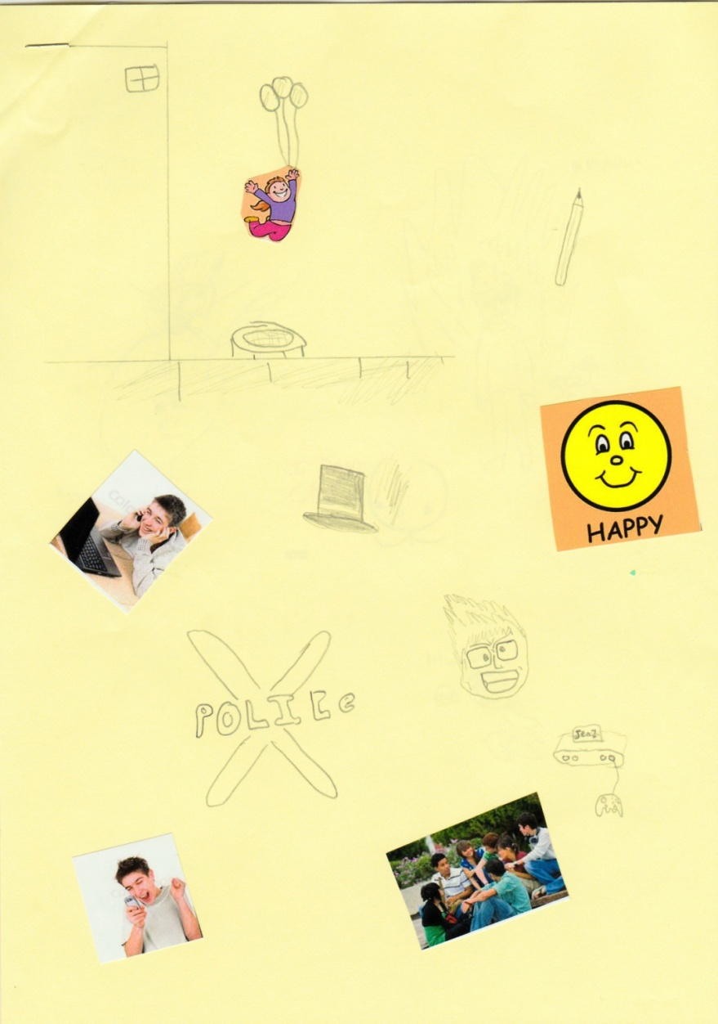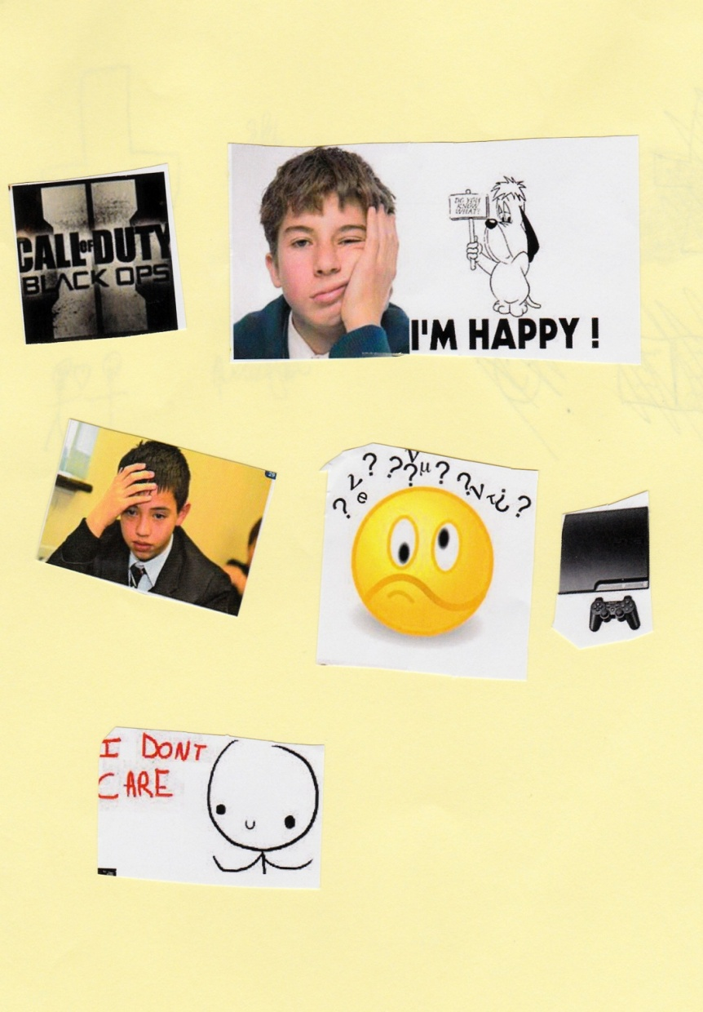

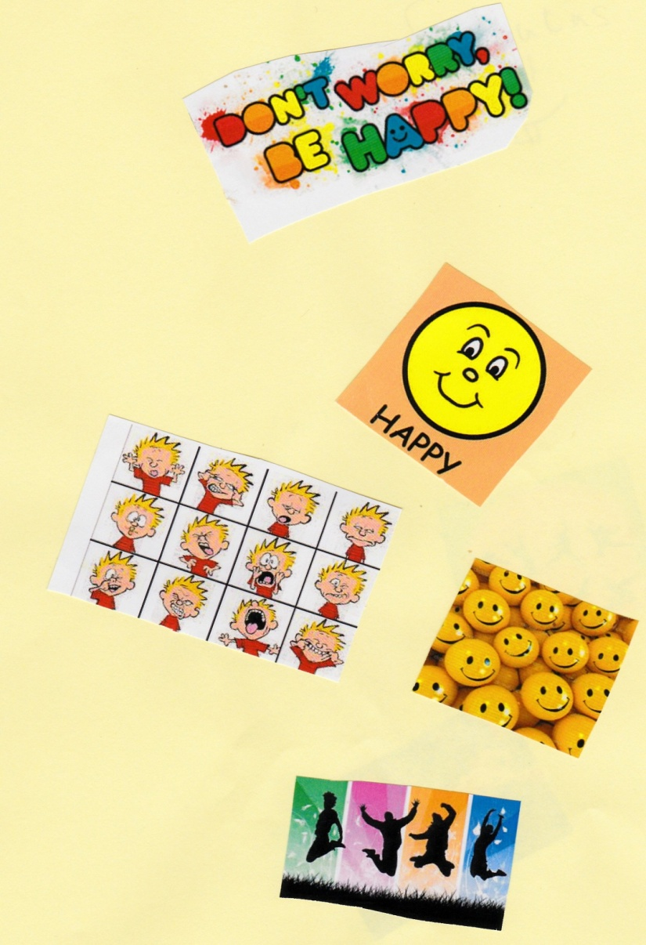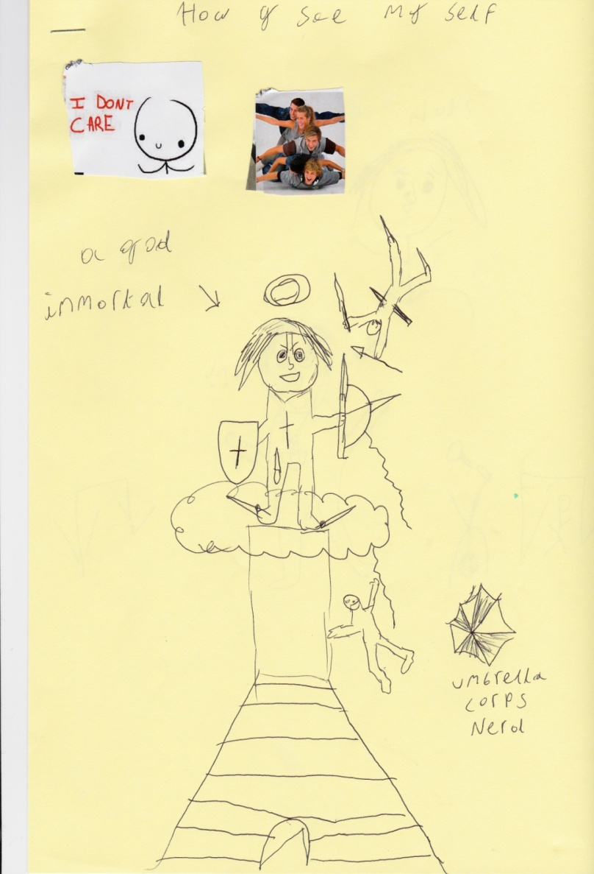

Appendix 2: Examples of raw data of how my friends see me

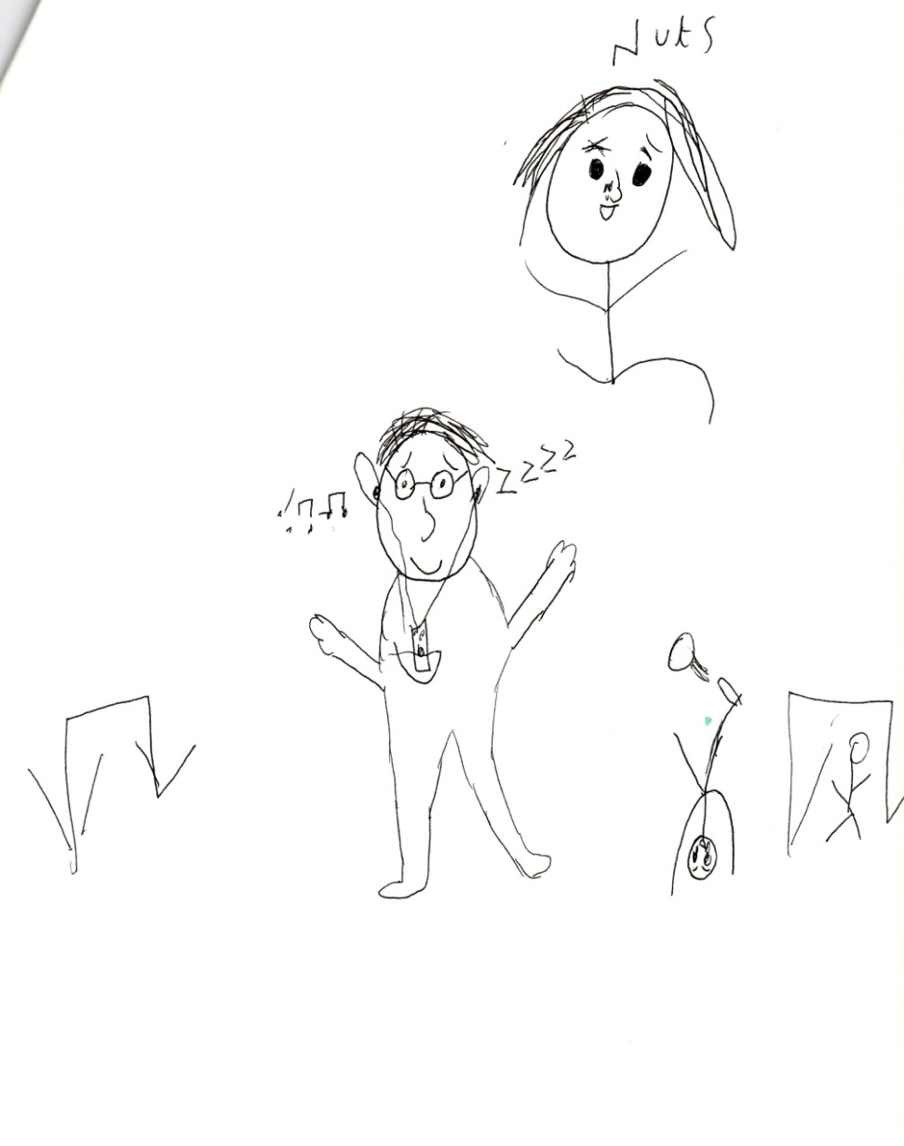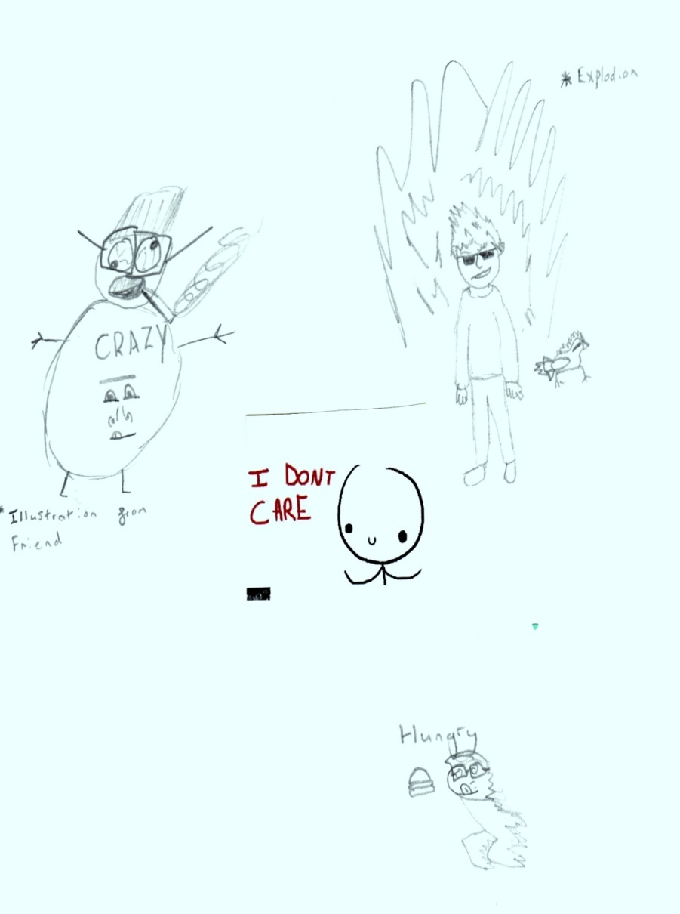

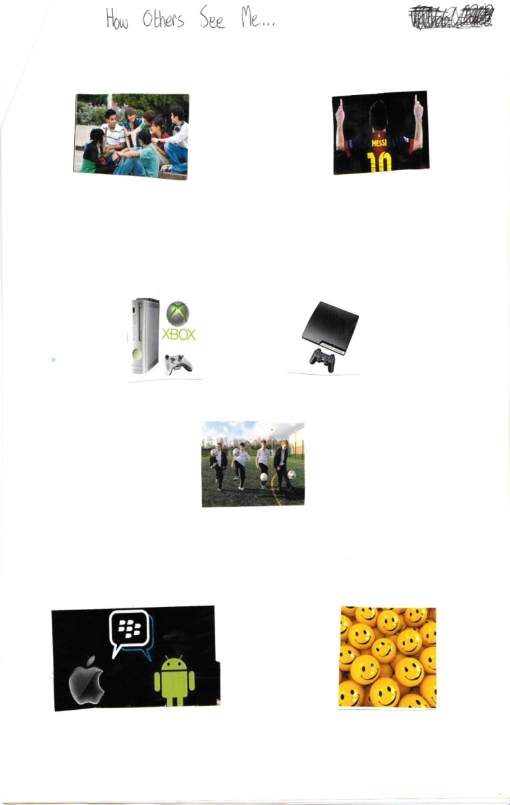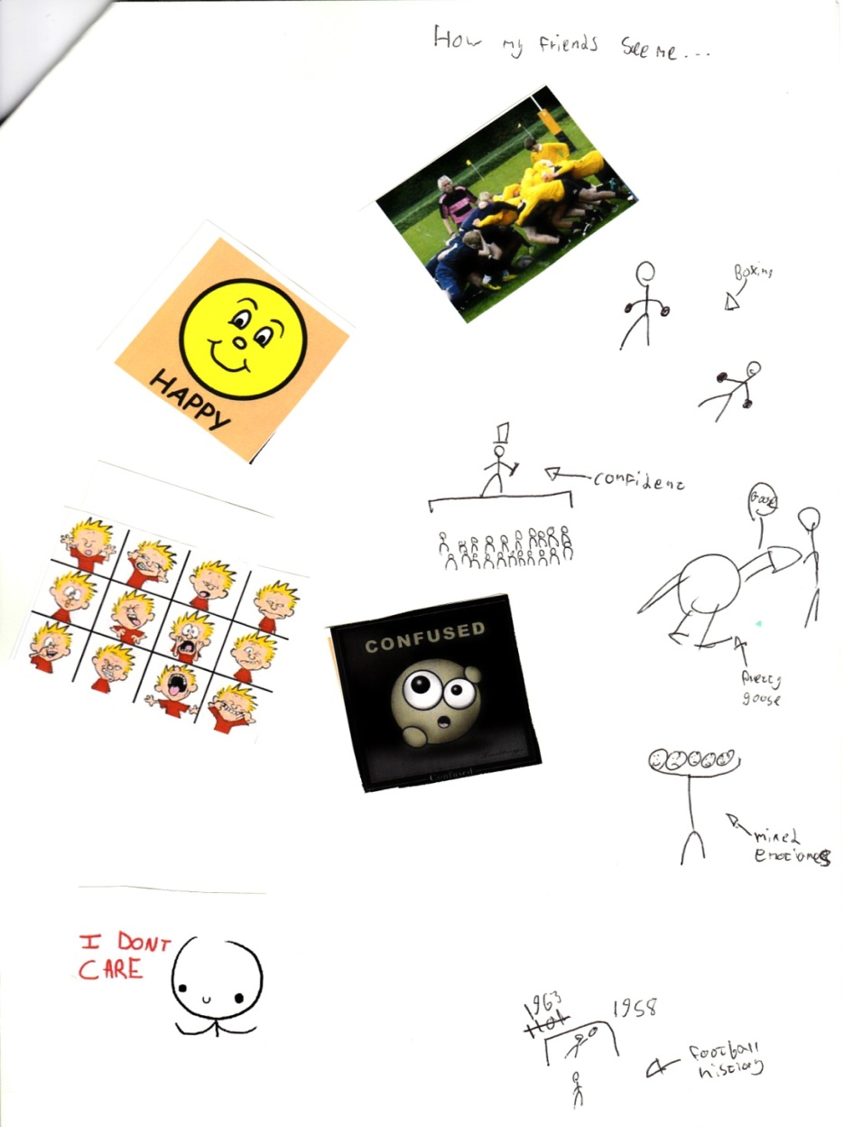

Appendix 3: Examples of raw data of how teachers and people in authority see me

